Warning – Oil Maintenance – PHEV

Functional Description

The IPC shall display the engine oil maintenance pop-up message if either of the engine on reasons transition to the Oil Maintenance mode state (EngOnMsg1_D_Dsply OR EngOnMsg2_D_Dsply transition to the "Oil Maintenance" state).

The PHEV oil maintenance mode for GEN 3 PHEV's is expected to force an engine pull-up for ~15 minutes with noticeable impact to drivability, so the intent of this message is to inform the driver of the reason the engine is on.

Interfaces

Interface Context Diagram (I/O Block Diagram)

- Warning – Oil Maintenance Warning Function Context Diagram

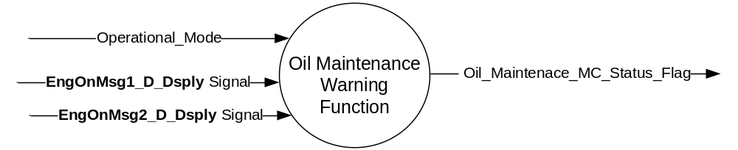

Inputs

- INTERNAL:

- Operational_Mode

- MUX signals

- EngOnMsg1_D_Dsply Signal

Signal Name | Size (bits) | Detail | Units | Res. | Offset | State Encoded | Min | Max
EngOnMsg1_D_Dsply | 5 |  | SED | 1 | 0 |  | 0 (0x0) | 11 (0xB)
 |  | No Display |  |  |  | 0x0
 |  | Acceleration |  |  |  | 0x1
 |  | High Speed |  |  |  | 0x2
 |  | Heater Setting |  |  |  | 0x3
 |  | Neutral Gear |  |  |  | 0x4
 |  | Engine Cold |  |  |  | 0x5
 |  | Batt Charging (High Voltage) |  |  |  | 0x6
 |  | Low Gear |  |  |  | 0x7
 |  | Normal Operation |  |  |  | 0x8
 |  | Oil Maintenance |  |  |  | 0x9
 |  | Fuel Maintenance |  |  |  | 0xA
 |  | Hill Decent Control |  |  |  | 0xB
 |  | Battery Temperature |  |  |  | 0xC
 |  | Not Used |  |  |  | 0xD - 0x1F

- EngOnMsg2_D_Dsply Signal

Signal Name | Size (bits) | Detail | Units | Res. | Offset | State Encoded | Min | Max
EngOnMsg2_D_Dsply | 5 |  | SED | 1 | 0 |  | 0 (0x0) | 11 (0xB)
 |  | No Display |  |  |  | 0x0
 |  | Acceleration |  |  |  | 0x1
 |  | High Speed |  |  |  | 0x2
 |  | Heater Setting |  |  |  | 0x3
 |  | Neutral Gear |  |  |  | 0x4
 |  | Engine Cold |  |  |  | 0x5
 |  | Batt Charging (High Voltage) |  |  |  | 0x6
 |  | Low Gear |  |  |  | 0x7
 |  | Normal Operation |  |  |  | 0x8
 |  | Oil_Maintenance |  |  |  | 0x9
 |  | Fuel_Maintenance |  |  |  | 0xA
 |  | Hill_Decent_Control |  |  |  | 0xB
 |  | Battery Temperature |  |  |  | 0xC
 |  | Not Used |  |  |  | 0xD - 0x1F

Outputs
- INTERNAL:

- Oil_Maintenence_MC_Status_Flag

Function/Performance

Operational Modes

Mode | Differentiating Vehicle Conditions
Sleep Mode | Oil Maintenance Warning Disabled
Limited Mode | Oil Maintenance Warning Disabled
Normal Mode | Oil Maintenance Warning Enabled / Disabled
Crank Mode | Oil Maintenance Warning Enabled / Disabled

Voltage Levels

Refer to the Cluster Features table located in the Operational Modes and Voltage Range Strategies Section in this SPSS.

Human-Machine Interface

Visual

Indicator Graphics / Display Format

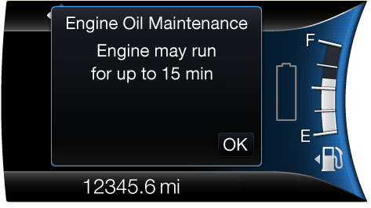
W702

For actual display, refer to the latest HMI graphics and setup messages.

Indicator Color Coordinates

Reference section COLOR & ILLUMINATION REQUIREMENTS (GRAPHICS)

Indicator Characteristics

Refer to Message Center X Display_Y Button Interface Section, where X and Y are appropriate values in this document.

Audio

None

Switch Control Logic

N/A

System Accuracy

Within a 100msec of receiving a message that results in a change of state the cluster will update the display to the proper status.

Operation: Performance and Functional

Subsystem Algorithm Flowchart / State Diagram

- Oil Maintenance Warning Flag State Matrix*

Operational_Mode | EngOnMsg1_D_Dsply signal | EngOnMsg2_D_Dsply signal | Oil_Maintenance_MC_Status_Flag
Normal or Crank | 0x9  (Oil Maintenance) | X | Active (0x1)
Normal or Crank | X | 0x9  (Oil Maintenance) | Active (0x1)
All Other Cases |  |  | Inactive (0x0)

*Notes:
- “X” means “Do not care”

- Since either of the two signals, EngOnMsg1_D_Dsply or EngOnMsg2_D_Dsply, may make the Oil_Maintenance_MC_Status_Flag “Active”, note that when one of the signals changes to “0x9” while the warning is already “Active” there is no state change, (i.e. Warning is not “new”.)

Operation Description (supports algorithm flowchart /state diagram)

- Oil Maintenance Warning Flag to MC Warning Message ID

Warning Flag | Warning #
Oil_Maintenance_MC_Status_Flag | W702

- For definition of how the Message Center arbitrates and displays Active warnings, see the Warning / Alert Display Logic Diagram, located in the Message Center – X Display with W Button Interface section of this SPSS (where X and W are appropriate values in this document).

Function Safety Classification (EMC)

Class B

Memory Storage

Parameter Name | Description | Value at  Battery Connect | Value at  Module Wake-up
EngOnMsg1_D_Dsply signal | CAN signal, transmitted by the HPCM to indicate the highest priority engine on reason for display. | 0x0 | 0x0
EngOnMsg2_D_Dsply signal | CAN signal, transmitted by the HPCM to indicate the second highest priority engine on reason for display. | 0x0 | 0x0
Oil_Maintenance_MC_Status_Flag | Internal status flag to indicate whether or not the Oil Maintenance warning should be displayed | Inactive (0x0) | Inactive (0x0)
Operational_Mode | 4 state indicator for cluster operational mode | Limited | Limited, Normal or Crank

Prove Out

Not applicable

Reconfigurable Telltale

Not Applicable

Message Center Msg

Warning Message ID W702 as defined in the Text Message List section of this SPSS.

Error Handling

Missing Message Strategy

None

Diagnostics

Self Test

None

Engineering Test Mode

Reference section “Dealer / Engineering Test Mode (ETM)”

Part II Performance

Supported Diagnostic Trouble Codes (DTCs)

DTC | Description
None

Reference Specification

  - CAN Database
  - DIDC
  - Message Center Warnings

Revision History
SPSS Module Revision History

Revision Level | Name | Change Description | Date
1.0 | S. Watkins | Initial Release. Updated from legacy non-CGEA version 1.1. | 9/20/2016

